Table including all algorithms at 50 samples

|  |  |  |  |  |  |  |  |  |  |
| --- | --- | --- | --- | --- | --- | --- | --- | --- | --- |
| **Algorithms** | **Rayleigh Var=1** | **Rayleigh Var=2** | **Rician Var=1** | **Rician Var=2** | **Nakagami Var=1**  **M=0.5** | **Nakagami**  **Var=1**  **M=1** | **Nakagami**  **Var=1 M=1.5** | **Nakagami**  **Var=1**  **M=2** | **AWGN:** |
| Linear SVM | 0.8646 | 0.9376 | 0.9041 | 0.9677 | 0.8114 | 0.8592 | 0.8871 | 0.9042 | 0.9618 |
| Logistic | 0.8642 | 0.9373 | 0.9043 | 0.9661 | 0.8094 | 0.8613 | 0.8753 | 0.9039 | 0.9580 |
| MLP | 0.8615 | 0.9372 | 0.8933 | 0.9656 | 0.7982 | 0.8587 | 0.8804 | 0.8874 | 0.9592 |
| Gaussian SVM | 0.8624 | 0.9353 | 0.9038 | 0.9680 | 0.8110 | 0.8619 | 0.8896 | 0.8937 | 0.9617 |
| OR | 0.8434 | 0.9258 | 0.8787 | 0.9579 | 0.8006 | 0.8436 | 0.8619 | 0.8756 | 0.9295 |
| MRC | 0.8571 | 0.9252 | 0.9020 | 0.9631 | 0.7977 | 0.8577 | 0.8856 | 0.9016 | 0.9618 |
| Naïve Bayes | 0.8459 | 0.9250 | 0.8909 | 0.9637 | 0.7970 | 0.8477 | 0.8778 | 0.8927 | 0.9600 |
| XGBoosts | 0.8349 | 0.9142 | 0.8926 | 0.9645 | 0.7945 | 0.8361 | 0.8457 | 0.8919 | 0.9395 |
| CatBoost | 0.8474 | 0.9218 | 0.8856 | 0.9622 | 0.7794 | 0.8484 | 0.8668 | 0.8772 | 0.9503 |
| ADABoost | 0.8376 | 0.9203 | 0.8816 | 0.9594 | 0.7878 | 0.8492 | 0.8683 | 0.8801 | 0.9427 |
| RandomForest | 0.8211 | 0.9183 | 0.8579 | 0.9598 | 0.7555 | 0.8363 | 0.8583 | 0.8707 | 0.9247 |
| KNN | 0.8407 | 0.9109 | 0.8859 | 0.9610 | 0.7741 | 0.8227 | 0.8728 | 0.8727 | 0.9444 |
| S1 | 0.8437 | 0.9092 | 0.8924 | 0.9552 | 0.7812 | 0.8448 | 0.8753 | 0.8923 | 0.9580 |
| S2 | 0.6453 | 0.7275 | 0.6548 | 0.7571 | 0.6247 | 0.6453 | 0.6474 | 0.6502 | 0.6617 |
| AND | 0.6718 | 0.7357 | 0.6919 | 0.7642 | 0.6401 | 0.6704 | 0.6824 | 0.6905 | 0.7108 |
| S3 | 0.5546 | 0.6001 | 0.5524 | 0.6044 | 0.5531 | 0.5526 | 0.5474 | 0.5524 | 0.5522 |

Chapter 1:

Abstract: 3/4

Introduction: 1.5

Background: 1ish, what’s wrong with them

Objective: 5-6 points, my work

Outline: discussing in different chapters

Chapter 2:

Literature survey, paper by paper, by order

Background, strategies, rules

Fading channels

ML techniques

How It is integrated

Chapter 3:

Describe what I have done, cite models   
Add figures and cite, add results

What we have understood, conclusion, important parameters.

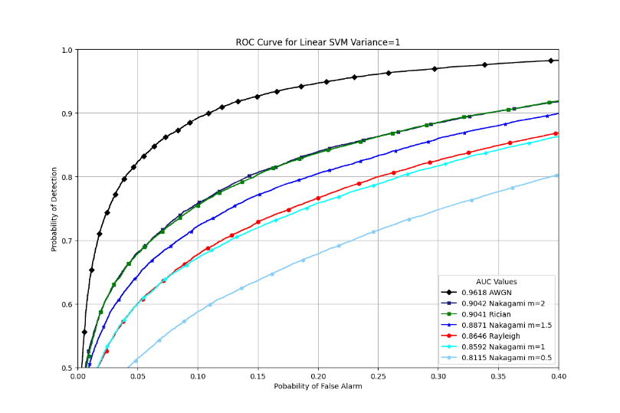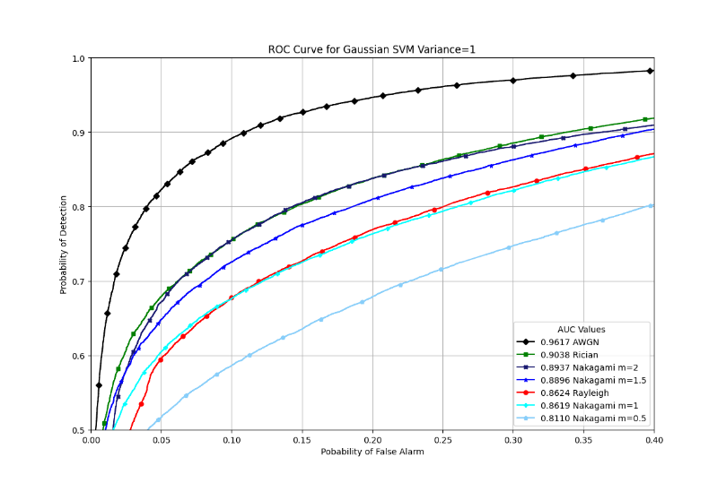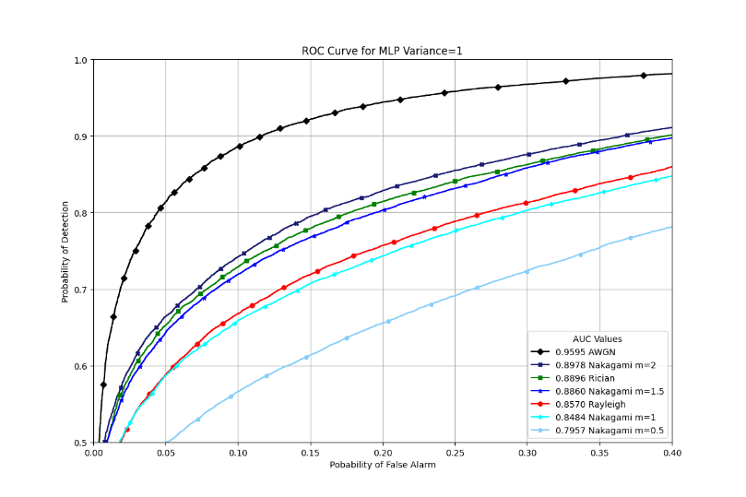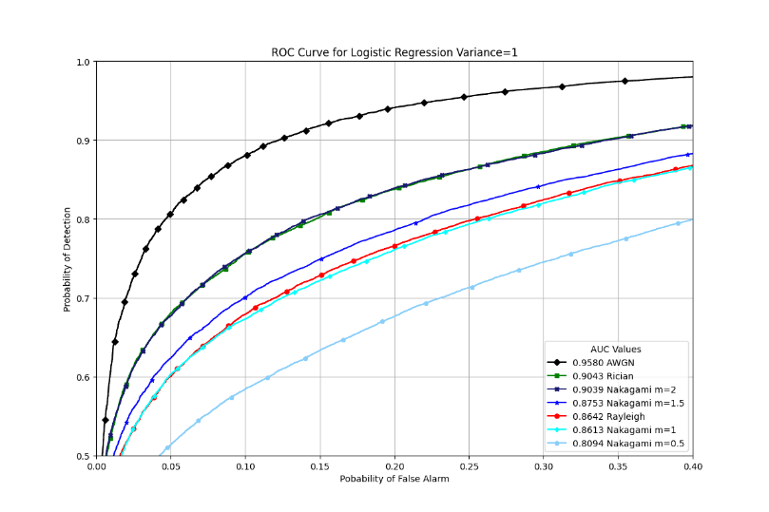

Fig 1 ROC Curves ML Algorithms for Rayleigh Fading $Variance=2$



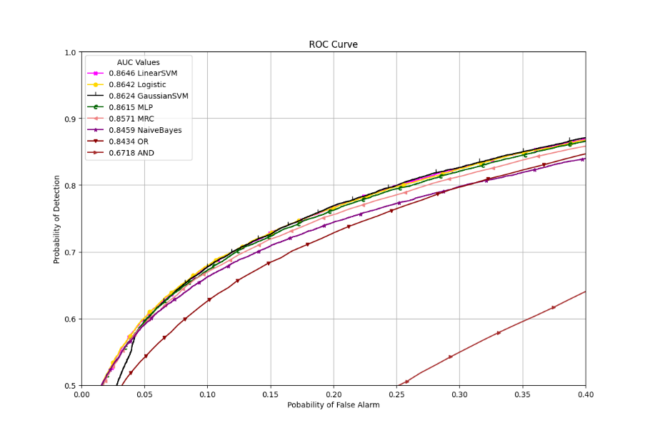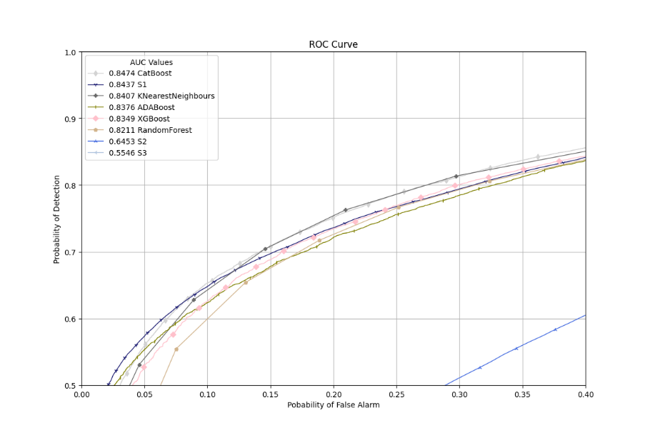

Fig 2 (i) (ii) ROC Curves for Rayleigh Fading

$$Variance=1$$

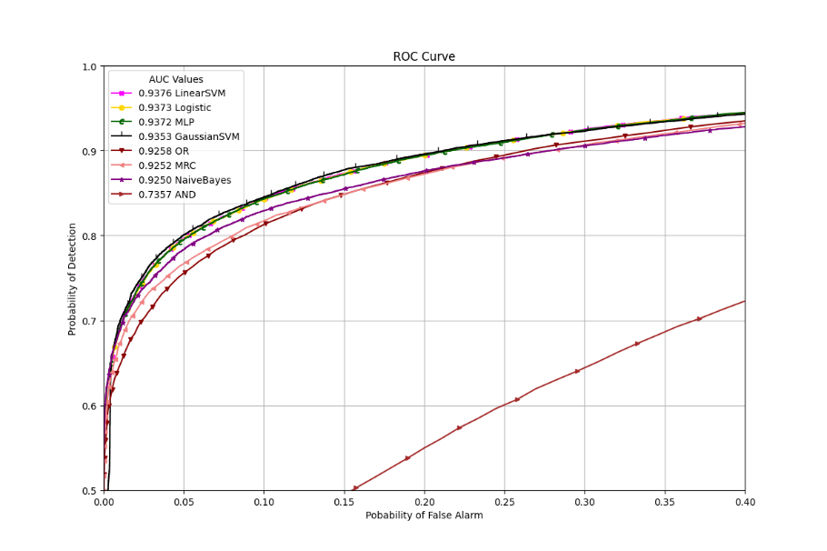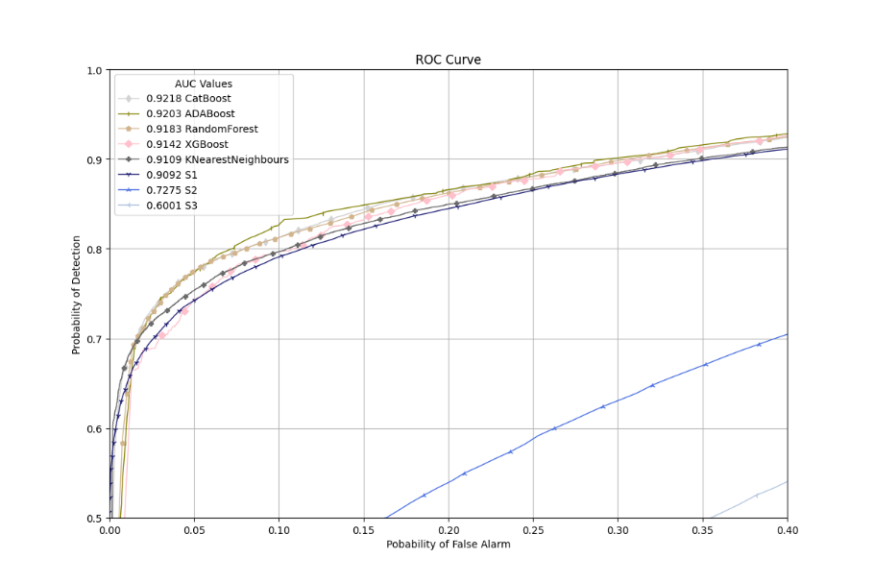

Fig 3 (i) (ii) ROC Curves for Rayleigh Fading

$$Variance=2$$

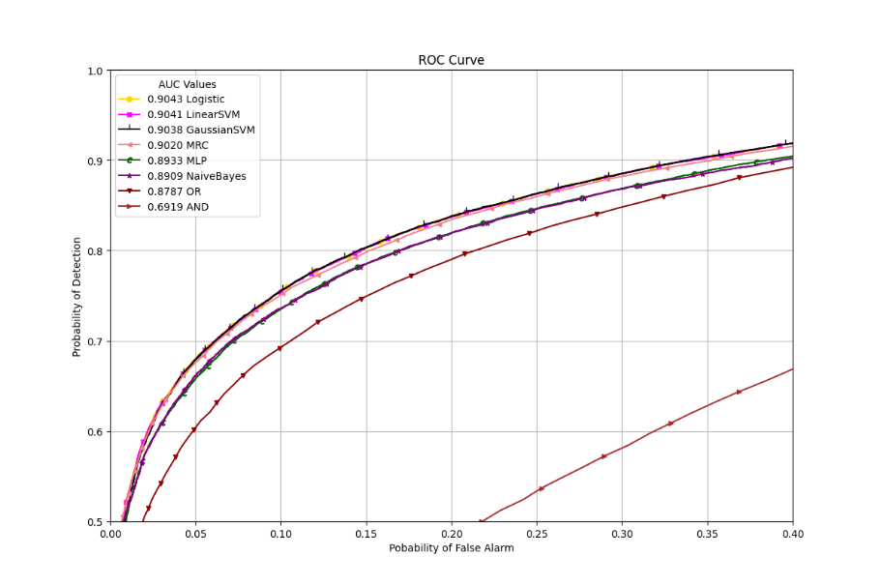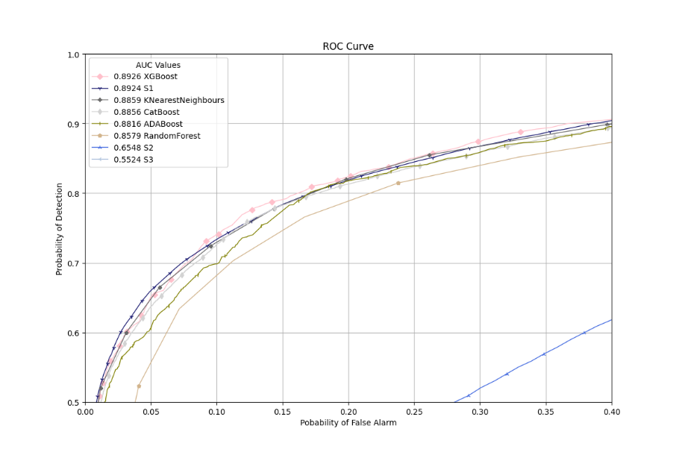

Fig 4 (i) (ii) ROC Curves for Rician Fading $Variance=1$

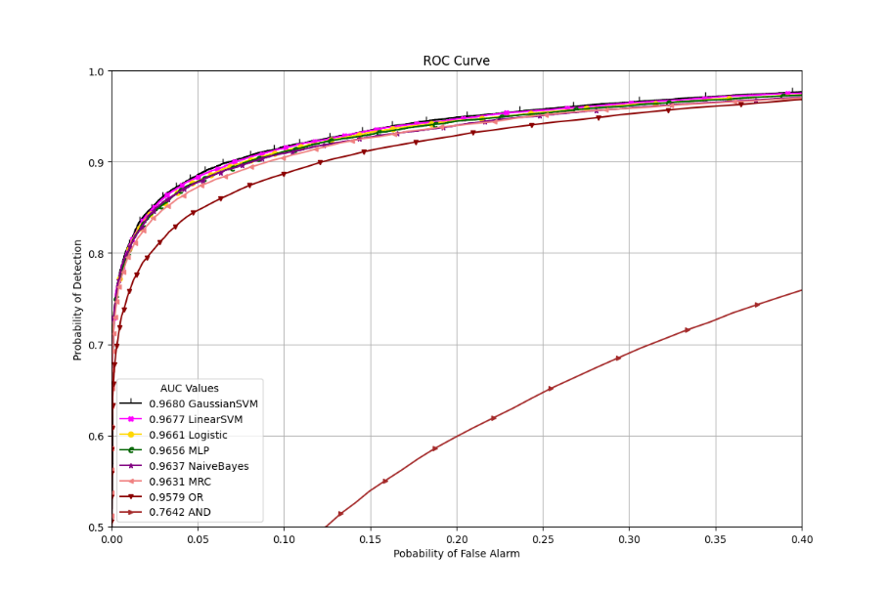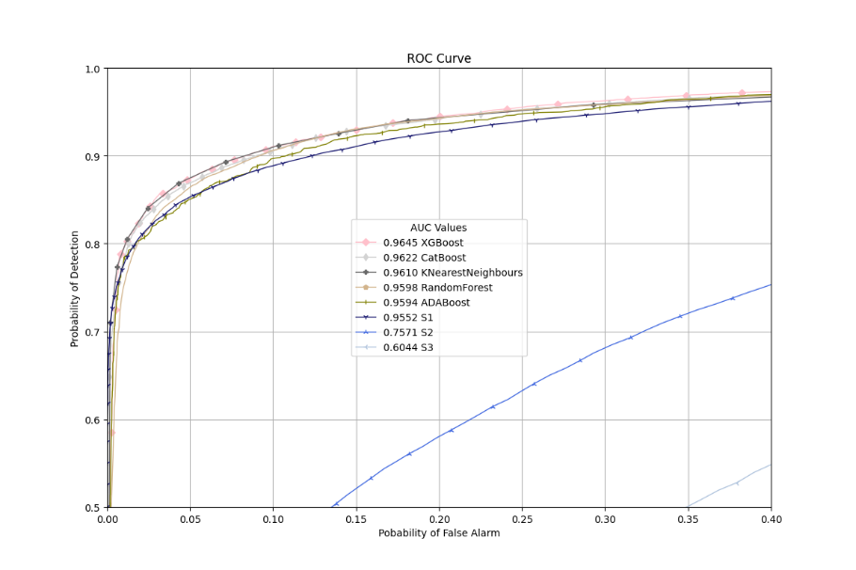

Fig 5 (i) (ii) ROC Curves for Rician Fading

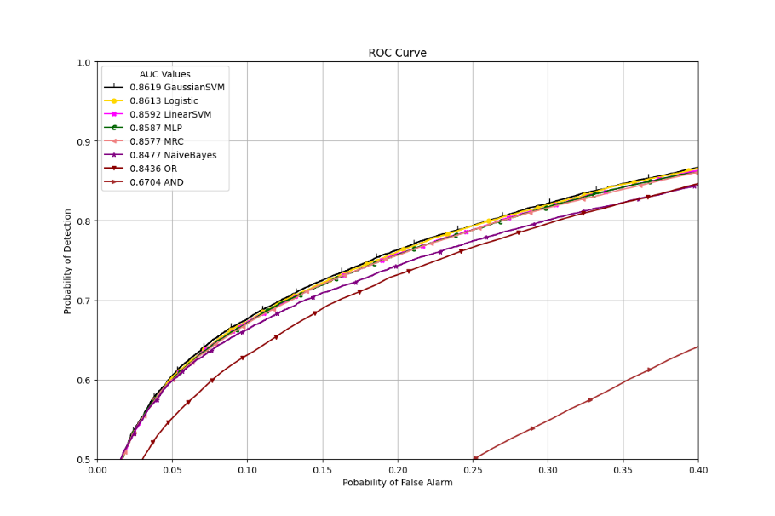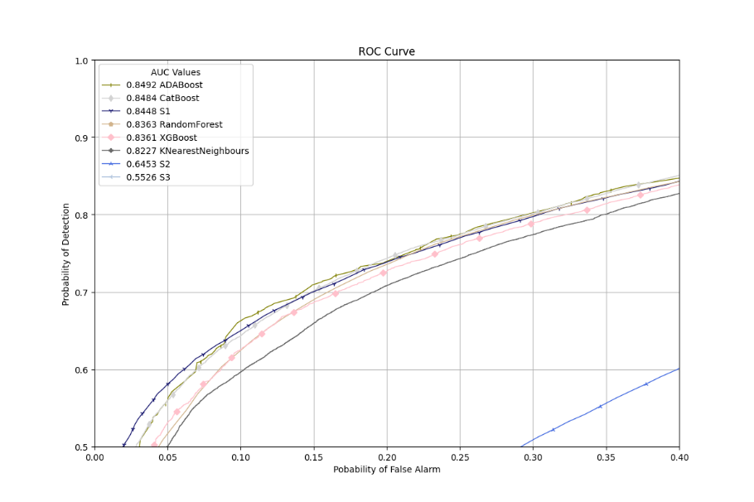

Fig 7 (i) (ii) ROC Curves for Nakagami Fading

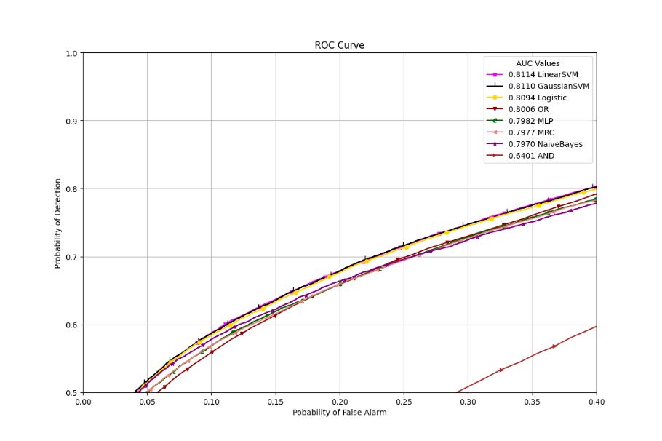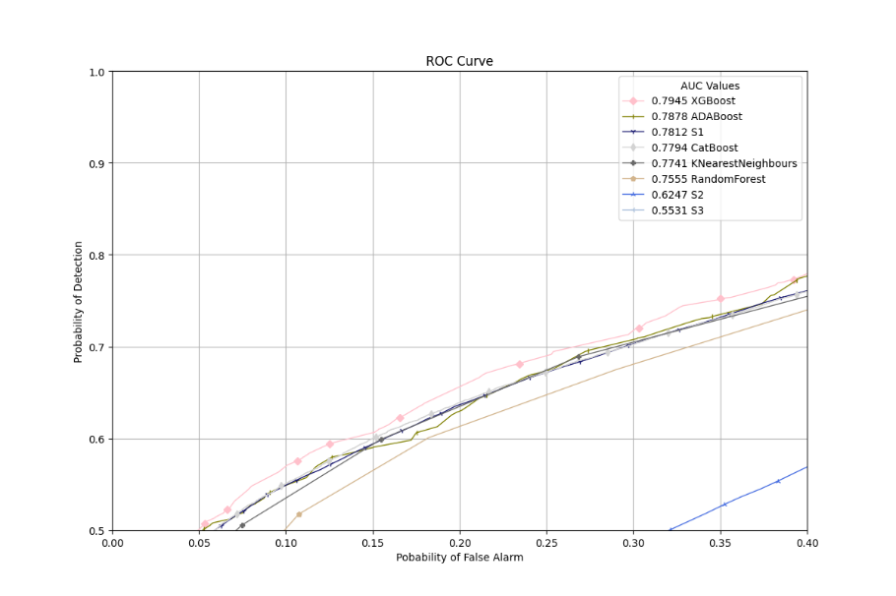

Fig 6 (i) (ii) ROC Curves for Nakagami Fading $Variance=1 M=0.5$

# 3.2 Related Work:

1. Used as base paper, added other machine learning algorithms to compare performance.
2. Authors have considered various fading scenarios and different noise environments. Co-operative (AND, OR, K Means Clustering) and noncooperative sensing used techniques.
3. The authors have not included machine learning algorithms. They have concentrated on SNR Walls, a threshold below which, no matter how long a detector senses, will fail to be robust because it gets tough to distinguish between the h0 and h1 hypotheses. They also discuss what happens on the other side of the SNR Wall, its impact, Spectrum Holes and SNR Walls in space, and how metrics reveal trade-offs and the importance of diversity.
4. Paper uses a type of Deep Learning model called a Convolutional Neural Network (CNN), mainly used for image classification and recognition. They are good at recognizing complex patterns in the given input (like gradients, shapes, and lines). They have focused on various modulation types (64QAM, B-FM, BPSK, CPFSK, DSB-AM, GFSK, PAM4, QPSK, SSB-AM), and the CNN models try to classify the input data and link it to one of these modulation types. They have also compared the performance of models in different published papers related to modulation types.
5. The paper mainly emphasizes Context Awareness in Wireless Communications which will improve the efficiency of existing services for which the authors have used Machine Learning and Deep Learning algorithms in various categories like Unsupervised Learning, Supervised Learning, and Reinforcement Learning. The authors have not focused on spectrum sensing.
6. Authors have used Machine Learning algorithms Decision Tree Classification and Random Forest Classification to train SNR, frequency, and the number of samples.
7. The Deep Reinforcement Learning technique has been used, which does not require a labeled dataset and can adapt to the environment with little human interaction. It works by rewarding or punishing the model for making decisions.
8. The paper does not include Machine Learning Algorithms. Authors wish to figure out sensing time that gives the best performance for SUs under different cases.
9. The paper focuses on Log-Normal Shadowing and Rayleigh Fading for Spectrum Sensing for various parameters like multiple SUs and distances. The authors did not use Machine Learning.
10. The paper considers that the PU transmits with discrete power levels with set probabilities, and Machine Learning is used twice. K Means Clustering is used first to label the dataset, and SVM learns from the dataset and the labels to predict if the PU is transmitting or not. Fading scenarios have not been considered.
11. SUs operate under a Hybrid Underlay-Interweave Model, meaning that the SUs can utilize the spectrum when the PU is not transmitting and simultaneously access it along with the PU while abiding by the Interference Temperature. Gassuain SVM, Linear SVM, Polynomial SVM, Gaussian Mixture Model (GMM), and Naive Bayes Machine Learning algorithms have been used to decide if the PU is active.
12. The paper only has Naive Bayes, Linear SVM, Gaussian SVM, and MLP. The paper does not concentrate on the effects of parameters like samples or SUs.
13. Artificial Neural Network, SVM, Decision Tree, and KNN were used to detect PUs presence. The dataset was generated using an Arduino Uno Card and a wireless transmitter (practical dataset). It was not formula-based, the downside being that the authors cannot determine the effects of parameters like the number of samples, distances, and types of fading and is limited to only 1 SU (Noncooperative Spectrum Sensing).
14. Multiple PUs exist and can be active, and SUs are considered mobile but at a relatively slow speed so that the Doppler effect can be ignored. Naive Bayes and Gaussian Mixture models are applied to detect if the band is free.
15. The authors have used the K-Nearest Neighbours algorithm trained on two training sizes along with the classical OR technique. Probability of Detection, Misdetection, and Error have been plotted against SNR and the number of SUs.
16. K-Means Clustering and SVM (linear and polynomial) have been used for classification. 2 and 9 SUs have been considered. Authors have shown how the Transmitting Power of the PU affects the Probability of Detection.
17. Under Unsupervised Learning algorithms, K-Means Clustering and GMM have been used for classification. Under Supervised Learning algorithms, SVM and K-Nearest Neighbours (with Euclidean and Cityblock distances) have been used for classification. The effect of Transmission Power of PU has also been expressed.
18. Like 7, use the Deep Reinforcement Learning technique to decide whether PU uses the spectrum band. Multiple Pus and a wideband channel are considered. K out of N, SVM, and DL models also have been compared for performance.
19. Authors have used KNN, SVM, Naive Bayes, Decision Tree algorithms, and classical techniques like AND, OR, and MRC. Accuracy, Precision, and Recall values for all algorithms have been provided.
20. The paper focuses on showing the effects of Malicious Users (MUs) and mitigating their effects. MUs send false data to the Fusion Center, which would affect the performance of Cooperative Spectrum Sensing. The authors have proposed a Hybrid Boosted Tree Algorithm based on Differential Evolution and the Boosted Tree Algorithm. This model has been compared to other models like the Genetic Algorithm and KNN. The authors have provided detailed results by running simulations with varying parameters like SNR values and population sizes.
21. 2 Supervised Learning Algorithms (SVM and KNN) have been combined with three feature vectors (Energy, Probability, and Distance Vectors). Along with Probability Detection, effects of parameters like Training Time, Training Size, number of SUs, and Classification Speed have also been illustrated.
22. The primary focus has been given to various types of fading scenarios. Only classical techniques and the K-Means Clustering algorithm have been used.
23. The scenario includes 2 PUs. Multiclass SVM, Binary SVM, Multiclass KNN, One vs. One, and One vs. All types of SVM are the used classifiers. Variations in sample sizes, SU numbers, and SNR values have been depicted.
24. Cooperative Spectrum Sensing has been performed by using an SVM. Three scenarios have been considered: Algorithm 1 has been used to distinguish MUs from SUs. Algorithm 2 has been used to separate redundant users from unique PUs. Algorithm 3 divides users into groups that can each fulfill sensing requirements. The authors want to demonstrate how grouping can provide benefits like reducing security issues and energy consumption.
25. 3 Models used: Neural Networks, Expectation-Maximization, and K-Means Clustering. The authors tested models on simulated and real signals to show theoretical and practical performance.
26. Authors have considered SVM, CNN, and Deep Reinforcement Learning models for Cognitive Radio and discuss how several aspects need improvement when applying algorithms for Cooperative Spectrum Sensing.
27. Authors have published a survey including various types of algorithms under Supervised Learning, Unsupervised Learning, and Reinforcement Learning algorithms from different branches of Machine Learning. The paper evaluates and compiles work from other research papers.
28. The authors discuss Conventional techniques, Advanced techniques, including various methods like Covariance-Based Sensing and Machine Learning techniques. Similar to 28, the paper condenses results from other research papers which have used different Machine Learning Algorithms.

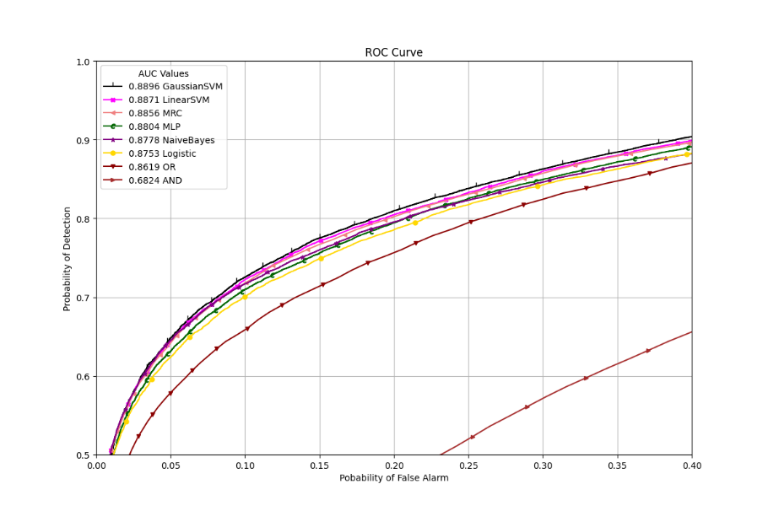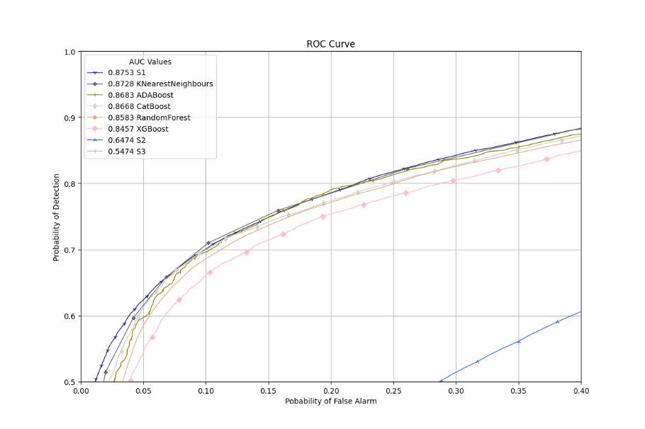

Fig 8 (i) (ii) ROC Curves for Nakagami Fading $Variance=1 M=1.5$

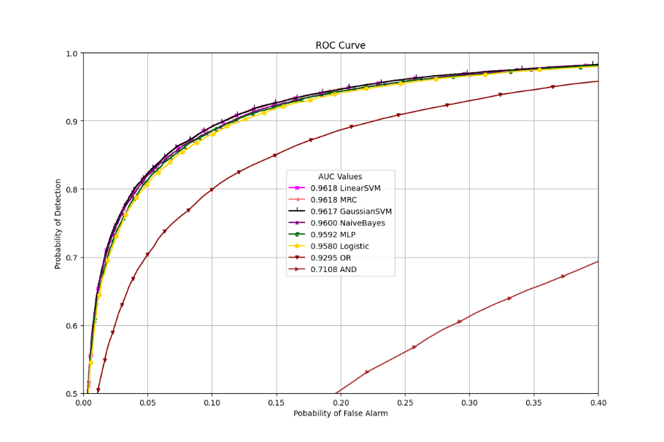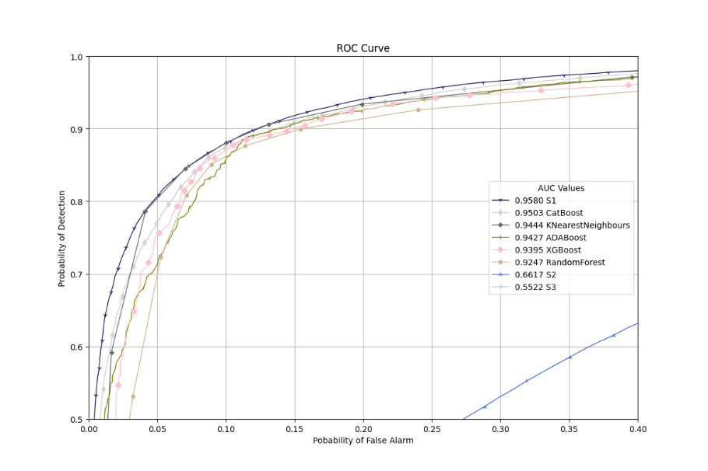

Fig 9 (i) (ii) ROC Curves for Nakagami Fading $Variance=1 M=2$

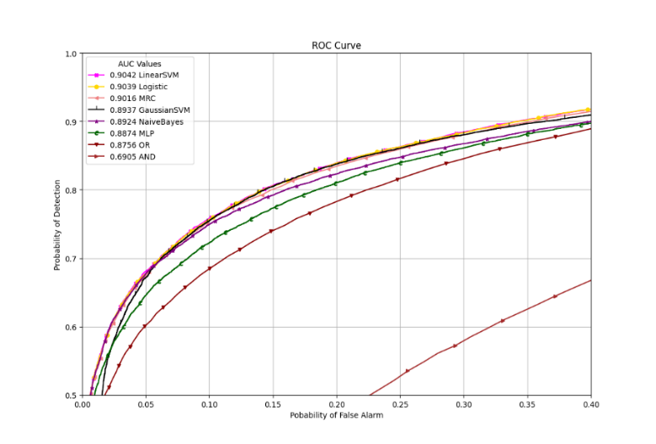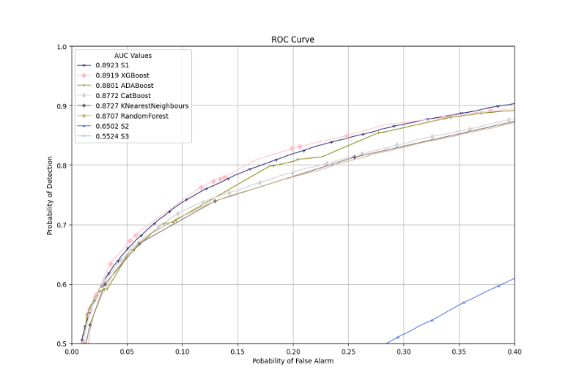

Fig 10 (i) (ii) ROC Curves for AWGN

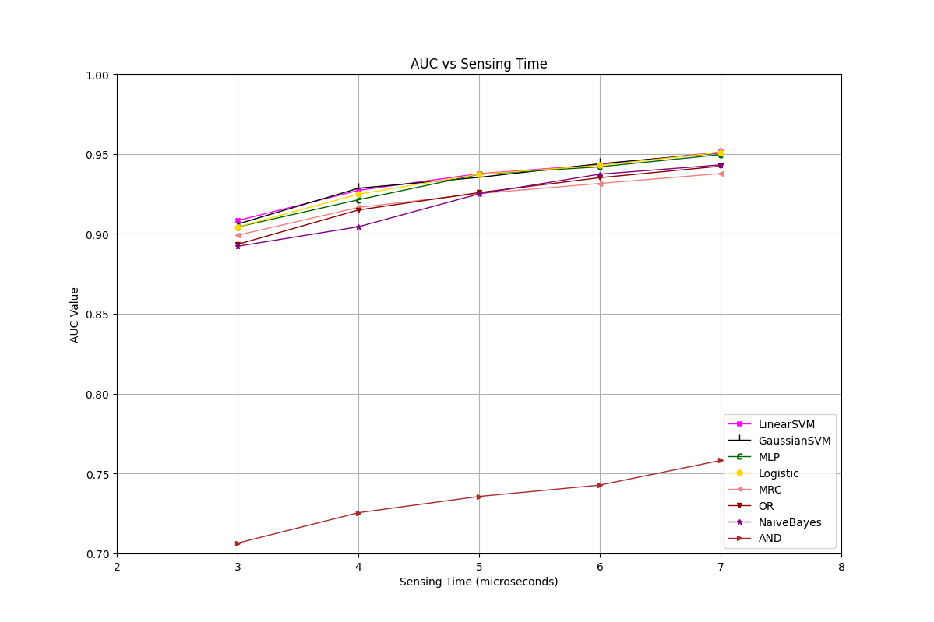

Fig 11 AUC vs Sensing Time for Rayleigh Fading $Variance=2$

AUC vs Training Dataset Size (Rayleigh Fading, 50 Samples, Variance 2)

|  |  |  |  |  |  |
| --- | --- | --- | --- | --- | --- |
| **Algorithms** | **50** | **100** | **250** | **500** | **1000** |
| Linear SVM | 0.9366 | 0.9344 | 0.9376 | 0.9360 | 0.9357 |
| Logistic | 0.9343 | 0.9344 | 0.9373 | 0.9305 | 0.9363 |
| MLP | 0.9107 | 0.9084 | 0.9372 | 0.9365 | 0.9364 |
| Gaussian SVM | 0.9378 | 0.9264 | 0.9353 | 0.9323 | 0.9358 |
| OR | 0.9259 | 0.9262 | 0.9258 | 0.9252 | 0.9248 |
| MRC | 0.9257 | 0.9237 | 0.9252 | 0.9256 | 0.9247 |
| Naïve Bayes | 0.9287 | 0.9152 | 0.9250 | 0.9250 | 0.9250 |
| XGBoost | 0.9192 | 0.9150 | 0.9142 | 0.9042 | 0.9274 |
| CatBoost | 0.9240 | 0.9124 | 0.9218 | 0.9213 | 0.9304 |
| ADABoost | 0.8931 | 0.9024 | 0.9203 | 0.9137 | 0.9280 |
| RandomForest | 0.9120 | 0.9026 | 0.9183 | 0.9128 | 0.9237 |
| KNN | 0.9288 | 0.9097 | 0.9109 | 0.9004 | 0.9228 |
| AND | 0.7365 | 0.7318 | 0.7357 | 0.7364 | 0.7363 |

AUC vs SU (Rayleigh Fading, 50 +Samples, Variance 2)

|  |  |  |  |  |  |  |
| --- | --- | --- | --- | --- | --- | --- |
| **Algorithms** | **2** | **3** | **4** | **5** | **6** | **7** |
| Linear SVM | 0.9094 | 0.9376 | 0.9569 | 0.9687 | 0.9766 | 0.9840 |
| Logistic | 0.9110 | 0.9373 | 0.9567 | 0.9687 | 0.9755 | 0.9844 |
| MLP | 0.9073 | 0.9372 | 0.9560 | 0.9652 | 0.9736 | 0.9822 |
| Gaussian SVM | 0.9109 | 0.9353 | 0.9572 | 0.9701 | 0.9792 | 0.9841 |
| OR | 0.9033 | 0.9258 | 0.9454 | 0.9574 | 0.9669 | 0.9733 |
| MRC | 0.9089 | 0.9252 | 0.9446 | 0.9600 | 0.9703 | 0.9785 |
| Naïve Bayes | 0.8896 | 0.9250 | 0.9490 | 0.9618 | 0.9749 | 0.9791 |
| XGBoost | 0.9052 | 0.9142 | 0.9462 | 0.9522 | 0.9689 | 0.9760 |
| CatBoost | 0.9043 | 0.9218 | 0.9481 | 0.9612 | 0.9726 | 0.9801 |
| ADABoost | 0.9026 | 0.9203 | 0.9437 | 0.9575 | 0.9691 | 0.9766 |
| RandomForest | 0.8946 | 0.9183 | 0.9346 | 0.9594 | 0.9712 | 0.9787 |
| KNN | 0.9009 | 0.9109 | 0.9430 | 0.9519 | 0.9696 | 0.9683 |
| AND | 0.7247 | 0.7357 | 0.7387 | 0.7461 | 0.7454 | 0.7356 |

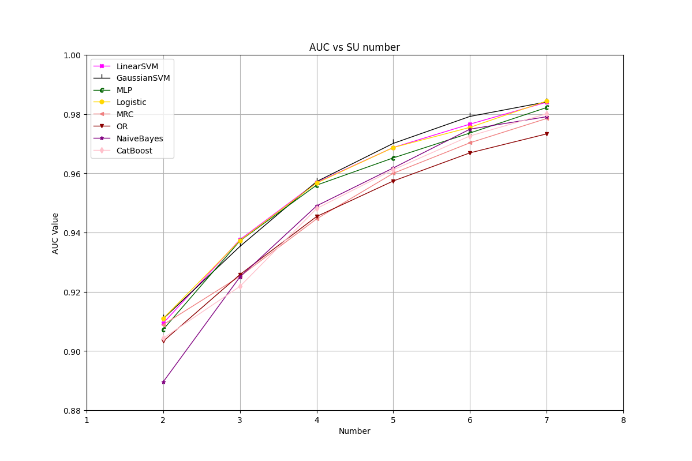

Fig 12 AUC vs SU Numbers for Rayleigh Fading $Variance=2$

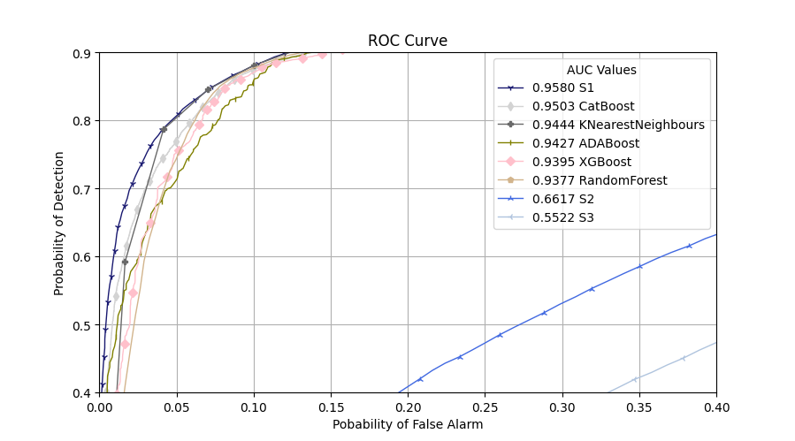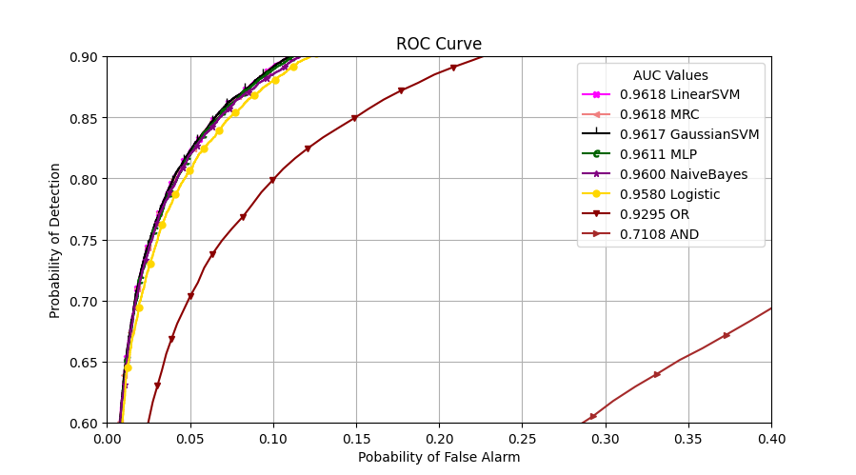

Fig 10 (i) (ii) ROC Curves for AWGN

